**FOOP202 – Lab 2 Exceptions**

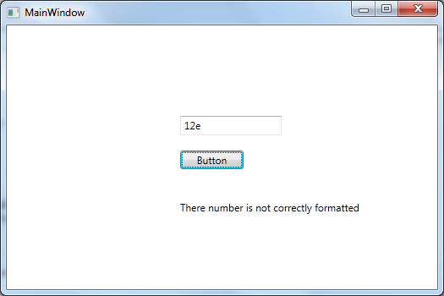**Examples**

**Ex 1**. A simple try/catch block. Create a form which takes the width of a square and returns the area. Can throw a FormatException. Can also use a finally block here.

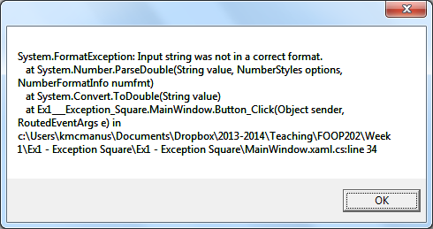

**Ex 2**. In the example above we displayed a simple message. Here we are going to use the Exception object with the Message property and ToString method to provide more detail.

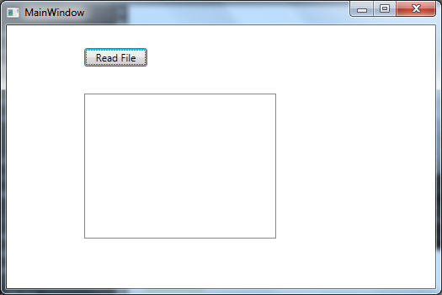

**Ex 3**. Here we are going to read a file and display to a Listbox. If the file is not found we will get a FileNotFoundException.

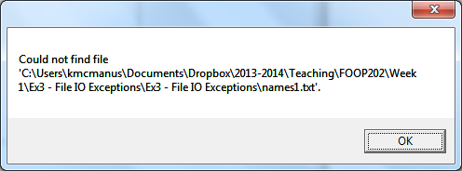

**Ex 4**. Multiple catch blocks. Here we are dividing 100 by the number entered on the screen.

|  |  |  |
| --- | --- | --- |
|  |  |  |

**Ex 5**. Throwing an exception. Word2Number. Here we have a TextBox and the user can enter ten, hundred or thousand and it is converted to a number. If the user enters a different number we throw a FormatException in the method, catch it and deal with it appropriately.

|  |  |  |
| --- | --- | --- |
|  |  |  |

**Exercises**

**Ex 6**. Write a program which provides two text boxes for the input of integer values a and b. Display the result of a/b and b/a. Incorporate exception handling for zero and non-numeric input text box values.

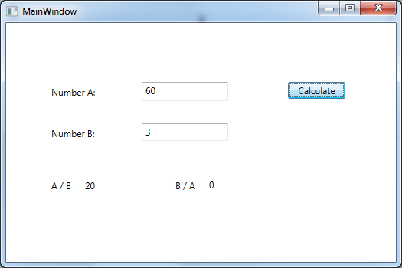

**Ex. 7**. Write a program which reads Name and Salary from a text file. It should handle a FileNotFound Exception if the file is not there and a FormatException if the salary is not in number format.

**Ex 8**. Write a method which solves quadratic equations. Normally there are two real roots. The method should take the form:

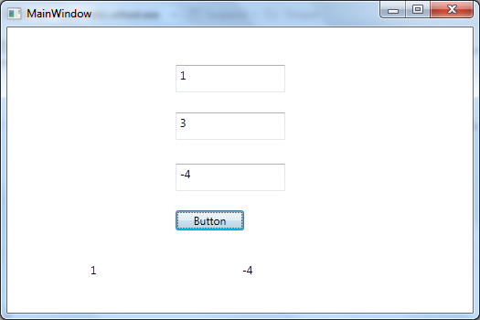Solve(a, b, c, root1, root2);

where roots are passed back as reference parameters. The formulae to calculate the roots are:

root1 = (-b + Math.Sqrt(b * b – 4 * a * c)) / (2 * a);

root2 = **(-b -** Math.Sqrt(b * b – 4 * a * c)) / (2 * a);

In the case where the discriminant b * b – 4 * a * c is negative throw an ArithmeticException with a suitable message. Write a calling method to catch the exception. Use x2 + 3x – 4 = 0 to test.

**Ex 9**. If you know the three sides of a triangle the area can be calculated by:

area = Math.Sqrt(s * (s – a) * (s – b) * (s – c));

where

s = (a + b + c)/2

Write a method for calculating and returning the area. Make it throw a suitable exception (with a message) when the three lengths cannot form a triangle. This will be the case if you are trying to get the square root of a negative number. Write a calling method which catches your exception. To test 3, 4 and 5 should give you an area of 6.

**Ex 10**. Write a program which inputs three strings from three text boxes representing day, month and year. Produce a suitable error message if an item is non-numeric, missing completely or specifies an impossible date.